|  |  |  |  |
| --- | --- | --- | --- |
| GROUP A | GROUP B | GROUP C | **GROUP D**  **1** |
|  |  |  | Robinson, Ray  Independent  Erwin, Warwick  Independent  **PETTY, Greg**  **Independent**  Cooper, Wayne  Independent |

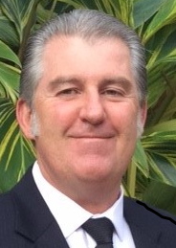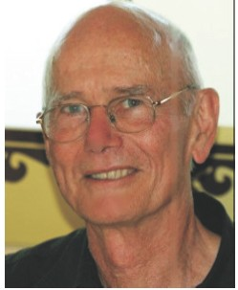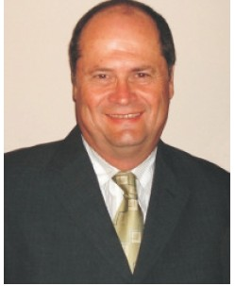

**Dr Ray ROBINSON**

Neighbourhood Forum 4 Treasurer/Community Mediation Expert

VOTE FOR

**Wollongong Independents**

**No party politics in local government**

Our pledge is to **protect**

the **people**, your **rights**

and our **community** **assets**.

**Wayne COOPER**

Neighbourhood Forum 4

Secretary/Customer Service Manager

**Warwick ERWIN**

Neighbourhood Forum 1

Convenor/Computer Network Engineer Manager

**Self-funded team,**

**we DO NOT accept political donations**

HOW TO VOTE: Place number **1** in box next to **PETTY, Greg**

Number the other boxes if you choose

How to Vote

**Greg PETTY** for Lord Mayor

**1**

**PETTY, Greg**

**Independent**

Cox, M

The Greens

2

Erwin, W

Independent

Anthony, A

Independent

Bradbery, G

Independent

Brown, D

Labor

3

Curran, V

Independent

Dorahy, J

Liberal

Mullan, J

Independent

**Greg PETTY**

**Current serving Wollongong Councillor**

***GREG’s EXPERIENCE***

Current Wollongong City Councillor

Proven advocate for the Community

40+ year local small businessman

Accountant (FCPA) & Company Secretary

Experienced Company Director

**GREG PETTY** INDEPENDENT ***your local community team***

Authorised by Greg Petty 130 Walker St, Helensburgh NSW 2508 Printed by Greg Petty 130 Walker Street, Helensburgh NSW 2508

✓

BALLOT PAPER FOR

ELECTION OF 4 COUNCILLORS

WARD ONE WOLLONGONG CITY COUNCIL ELECTION

HOW TO VOTE: Place number **1** in the box for **GROUP D**

If you choose, then number the other boxes above the line

**PLEASE CONSIDER THE ENVIRONMENT - RECYCLE or RETURN FOR REUSE**